An Experimental Evaluation of a Cognitive Overlay Digital Immune System for Kubernetes-based Cloud Environment

Ujwal Chhotu Thakare
Department of MCA Engineering
Met Bhujbal Knowledge City,
Nashik, India
ujwalt_ioe@bkc.met.edu

Mehraj Khan
Department of MCA Engineering
Met Bhujbal Knowledge City,
Nashik, India
meharh_ioe@bkc.met.edu
Sonali Vidhate
Department of MCA Engineering
Met Bhujbal Knowledge City,
Nashik, India
sonaliv_ioe@bkc.met.edu

Pritee Fuldeore
Department of MCA Engineering
Met Bhujbal Knowledge City,
Nashik, India
priteef_ioe@bkc.met.edu
Abstract— Cloud-native platforms such as Kubernetes introduce highly dynamic, distributed, and ephemeral workloads, significantly reducing the effectiveness of traditional static and rule-based security mechanisms. Although Digital Immune Systems (DIS) have recently emerged as a promising paradigm for autonomous cybersecurity, most existing approaches remain largely conceptual or are limited to isolated detection components without closed-loop automation or reproducible experimental validation.
This paper presents the design and experimental evaluation of a Cognitive Overlay Digital Immune System (DIS) implemented for Kubernetes-based cloud-native environments and extensible to broader enterprise infrastructures. The proposed system operates as a non-intrusive behavioral security overlay and adopts a biologically inspired architecture consisting of artificial dendritic cell agents for distributed runtime telemetry collection, a T-Helper detection layer based on unsupervised machine learning models (Isolation Forest and Autoencoder), and a B-Cell response layer capable of executing Kubernetes-native remediation actions. Unlike conventional security solutions, the DIS continuously observes system behavior and autonomously detects and responds to anomalies without inspecting application payloads or disrupting application logic.
To validate feasibility and operational effectiveness, an end-to-end experimental framework is implemented using synthetic runtime telemetry, controlled fault injection, and automated response execution within a Kubernetes cluster. Experimental results demonstrate that the ensemble detection layer achieves robust anomaly detection performance, attaining an AUPRC of 0.9813 with a precision of 0.9883 and recall of 0.9407, while successfully triggering appropriate containment and recovery actions through native Kubernetes mechanisms. All implementation artifacts, datasets, and experimental workflows are made publicly available to support reproducibility.
The findings demonstrate that Digital Immune Systems can be practically operationalized as autonomous, cloud-native security mechanisms, bridging the gap between immune-inspired theory and deployable enterprise security systems. This work establishes a reproducible foundation for future research on adaptive, self-healing cybersecurity architectures for modern digital infrastructures.

Keywords— Digital Immune System, Cognitive Overlay Security, Kubernetes Security, Behavioral Anomaly Detection, Self-Healing Systems, Runtime Telemetry.
- Introduction
Cloud-native computing has emerged as the dominant paradigm for deploying modern digital services, driven by the scalability, elasticity, and portability offered by container orchestration platforms such as Kubernetes. These platforms enable rapid application deployment, fine-grained resource management, and dynamic service composition. However, they also introduce highly dynamic execution environments in which workloads are short-lived, infrastructure components are frequently reconfigured, and system behavior continuously evolves at runtime. This volatility fundamentally challenges traditional security models that were designed for relatively static and predictable infrastructures.
Conventional security mechanisms in cloud environments primarily rely on predefined rules, static thresholds, and signature-based detection techniques. While effective against known threats, such approaches struggle to detect previously unseen or context-dependent anomalies that emerge from complex interactions among microservices, orchestration logic, and shared infrastructure. Moreover, the increasing scale and velocity of cloud-native systems place significant strain on human-centric monitoring and response workflows, rendering manual investigation and intervention progressively less effective. These limitations have motivated the exploration of autonomous security mechanisms capable of continuously observing system behavior and responding to threats with minimal human involvement.
Inspired by the adaptive and self-regulating properties of biological immune systems, Digital Immune Systems (DIS) have been proposed as a conceptual direction for next-generation cybersecurity. Biological immunity achieves resilience through distributed sensing, contextual anomaly recognition, memory formation, and localized response, enabling defense without exhaustive prior knowledge of threats. Prior research has explored immune-inspired techniques such as artificial immune systems, danger theory, and negative selection for intrusion detection and anomaly detection tasks. Despite their conceptual relevance, most existing DIS-oriented studies remain confined to theoretical frameworks, offline simulations, or isolated detection components. Critically, few works demonstrate a fully implemented Digital Immune System operating within a live cloud-native runtime, and even fewer provide reproducible experimental evidence of closed-loop detection and autonomous response.
This work addresses these limitations by presenting the design and experimental evaluation of a Cognitive Overlay Digital Immune System (DIS) for Kubernetes-based cloud-native environments, with extensibility to broader enterprise infrastructures. Rather than introducing a purely theoretical model, a complete DIS architecture is implemented as a non-intrusive behavioral security overlay that operates alongside an active Kubernetes cluster. The proposed system adopts a biologically inspired layered architecture comprising distributed runtime telemetry collection agents analogous to artificial dendritic cells, a T-Helper–inspired detection layer based on unsupervised machine learning models, and a B-Cell–inspired response layer responsible for executing Kubernetes-native remediation actions. By relying exclusively on behavioral telemetry, the DIS detects anomalous runtime behavior without inspecting application payloads or modifying application logic.
To evaluate feasibility and operational behavior, an end-to-end experimental framework is developed that integrates synthetic runtime telemetry generation, controlled fault injection, in-cluster anomaly detection, and automated response execution. The experiments are conducted in a Kubernetes environment and simulate realistic operational disruptions, including resource exhaustion and pod failures. Unlike studies that focus solely on detection accuracy, the evaluation emphasizes system-level behavior, response activation, and operational viability—key requirements for autonomous security systems in production cloud environments. All datasets, implementation artifacts, and experimental workflows are made publicly available to support reproducibility and further research.
The primary contributions of this work are summarized as follows:
- A biologically inspired Cognitive Overlay Digital Immune System architecture designed for Kubernetes-based cloud-native environments and extensible to enterprise-scale systems.
- A complete and reproducible implementation of the DIS, integrating distributed telemetry collection, unsupervised anomaly detection, and autonomous Kubernetes-native response mechanisms.
- An end-to-end experimental framework combining anomaly detection with chaos engineering to evaluate closed-loop detection and response under controlled fault conditions.
- An empirical evaluation demonstrating the feasibility of autonomous anomaly detection and response within a live cloud-native runtime.
The remainder of this paper is organized as follows. Section II reviews related work on immune-inspired cybersecurity, cloud-native anomaly detection, and autonomous response mechanisms. Section III presents the architecture and design principles of the proposed Digital Immune System. Section IV describes the experimental methodology and evaluation workflow. Section V reports experimental results and analysis, followed by discussion and limitations in Section VI. Section VII concludes the paper and outlines directions for future research.
- Related Work
Research related to Digital Immune Systems spans multiple domains, including immune-inspired cybersecurity, anomaly detection in cloud-native environments, and autonomous response mechanisms. This section reviews representative work in these areas and highlights the limitations that motivate the proposed approach.

II-A. Immune-Inspired Cybersecurity
Biologically inspired security mechanisms have been investigated for several decades, motivated by the adaptive, distributed, and self-regulating properties of the biological immune system. Early work in artificial immune systems explored techniques such as negative selection, clonal selection, and danger theory to distinguish normal behavior from anomalous or malicious activity [1], [2]. These approaches emphasized concepts such as self–non-self discrimination, tolerance, and immune memory, making them attractive for intrusion detection and anomaly detection tasks.
Subsequent studies applied immune-inspired models to network intrusion detection, host-based monitoring, and distributed security architectures [3], [4]. While these efforts demonstrated the conceptual viability of immune metaphors, most evaluations relied on offline datasets, controlled simulations, or narrowly scoped environments, limiting their applicability to dynamic, production-scale systems. In addition, many immune-inspired approaches focused primarily on detection and alert generation, without integrating autonomous response mechanisms capable of acting directly within the protected infrastructure.
More recent work has proposed high-level Digital Immune System frameworks emphasizing adaptability, self-healing, and resilience in modern computing environments [5], [6]. However, these proposals are often architectural or conceptual in nature, lacking concrete implementation details or experimental validation in cloud-native runtimes. As a result, the practical feasibility of deploying a complete Digital Immune System within container orchestration platforms such as Kubernetes remains insufficiently explored.

II-B. Anomaly Detection in Cloud-Native Environments
Anomaly detection has been extensively studied as a means of identifying deviations from normal behavior in complex systems. In cloud-native and containerized environments, anomaly detection techniques have been applied to runtime metrics such as resource utilization, network activity, and application performance indicators [7], [8]. Both supervised and unsupervised learning approaches have been explored, including statistical models, clustering-based methods, and neural network–based techniques.
Supervised anomaly detection methods require labeled datasets containing representative examples of both normal and anomalous behavior. While effective in controlled settings, such approaches are difficult to apply in cloud-native environments due to the scarcity of labeled attack data and the continuously evolving nature of workloads [9]. Consequently, unsupervised techniques such as Isolation Forests, autoencoders, and reconstruction-based models have gained prominence for detecting previously unseen anomalies without reliance on labeled data [10], [11].
Despite these advances, many anomaly detection solutions operate as external monitoring tools or offline analytics pipelines. They are often loosely coupled to the orchestration layer and do not directly support automated remediation. Furthermore, evaluations frequently focus on detection accuracy metrics alone, without considering system-level properties such as response latency, containment safety, or operational impact within a live cluster.

II-C. Autonomous Response and Orchestrated Defense
Autonomous response mechanisms aim to reduce dependence on manual intervention by automatically executing remediation actions in response to security-relevant events. Security Orchestration, Automation, and Response (SOAR) platforms represent a prominent class of such systems, enabling predefined playbooks to coordinate actions across multiple security tools and infrastructure components [12].
In cloud-native environments, automated response has also been explored through mechanisms such as auto-scaling, self-healing deployments, and policy-driven remediation [13]. Kubernetes natively provides primitives for restarting failed containers, rescheduling pods, and maintaining service availability. However, these mechanisms are primarily designed for fault tolerance and availability, rather than security-driven anomaly response.
Research integrating anomaly detection with autonomous response in Kubernetes remains limited. Existing approaches often rely on external controllers or centralized decision engines, which may introduce additional latency and system complexity [14]. Moreover, relatively few studies evaluate the safety, controllability, and operational impact of autonomous responses, particularly in scenarios where false positives could lead to unnecessary service disruption.

II-D. Summary and Positioning of This Work
In summary, prior research has explored immune-inspired security concepts, anomaly detection techniques, and automated response mechanisms largely in isolation. Existing Digital Immune System proposals are predominantly conceptual, while anomaly detection and response systems are often decoupled and evaluated independently. Consequently, there remains a lack of experimentally validated systems that integrate distributed sensing, adaptive detection, and autonomous response into a cohesive Digital Immune System operating within a real cloud-native runtime.
The present work addresses this gap by presenting a fully implemented Cognitive Overlay Digital Immune System for Kubernetes-based environments. The proposed system integrates distributed runtime telemetry collection, unsupervised anomaly detection, and Kubernetes-native autonomous response within a single, closed-loop architecture. Unlike prior conceptual or offline approaches, the system is evaluated through an end-to-end experimental workflow incorporating chaos engineering and in-cluster execution. By emphasizing reproducibility and system-level behavior, this work advances Digital Immune Systems from theoretical constructs toward practical, deployable security mechanisms for cloud-native and enterprise infrastructures.

III. SYSTEM ARCHITECTURE
The proposed Cognitive Overlay Digital Immune System (DIS) is designed as a modular, non-intrusive security architecture that operates alongside a Kubernetes-managed cloud-native environment. Rather than replacing existing security controls or orchestration mechanisms, the DIS functions as a cognitive overlay that continuously observes runtime behavior, detects anomalous conditions, and triggers controlled remediation actions using native Kubernetes primitives. The architecture is inspired by the functional organization of the biological immune system and emphasizes distributed sensing, adaptive decision-making, and localized response.

III-A. Design Principles
The architecture of the proposed DIS is guided by the following design principles.
Non-intrusive operation: The DIS is deployed as an overlay that does not modify application code or core Kubernetes components. This ensures compatibility with existing workloads and minimizes operational risk during deployment and execution.
Distributed sensing: Security-relevant observations are collected locally at each node, reducing reliance on centralized monitoring components and improving scalability in highly dynamic cluster environments.
Adaptive detection: Anomaly detection relies on unsupervised learning models capable of identifying deviations from normal system behavior without requiring labeled attack data, which is often unavailable in cloud-native environments.
Kubernetes-native response: All remediation actions are executed using standard Kubernetes APIs, ensuring predictable behavior and alignment with cluster governance and access-control policies.
Reproducibility and explainability: The system prioritizes well-understood models and transparent workflows to support experimental validation, interpretability, and reproducibility of results.

III-B. Biological-to-Digital Mapping
The DIS architecture adopts a functional mapping between biological immune system components and corresponding digital system elements. This mapping serves as a conceptual guide for system design while remaining grounded in practical implementation constraints.

III-C. Cognitive Overlay Concept
The DIS operates as a cognitive overlay, meaning that it observes and reasons about system behavior without directly interfering with application execution. Runtime metrics are collected continuously and evaluated in parallel with normal workload operation. Detection and response decisions are therefore decoupled from application logic, reducing the risk of unintended side effects.
This overlay-based approach enables incremental deployment in existing Kubernetes clusters without architectural changes. It also allows security decisions to be derived from holistic system context rather than isolated events and supports extensibility by permitting additional detection models or response strategies to be integrated without redesigning the core system.
The biological-to-digital correspondence used in this work is summarized as follows:

Biological Immune Component | Digital Immune System Component
Antigen | Runtime system metrics (CPU, memory, I/O, network)
Artificial dendritic cell | Distributed metric collection agent
T-helper cell | Anomaly detection and decision logic
B-cell | Autonomous response controller
Immune memory | Persisted detection models and thresholds
This mapping enables immune-inspired behavior without relying on direct biological analogies that are difficult to operationalize in software systems.

III-D. Distributed Sensing Layer (Artificial Dendritic Cells)
The lowest layer of the DIS architecture consists of distributed sensing agents deployed as a Kubernetes DaemonSet. Each agent operates on a node and collects local runtime metrics, including resource utilization and system performance indicators. These metrics function as digital antigens representing the current operational state of the system.
By colocating sensing agents with workloads, the DIS minimizes observation latency and avoids bottlenecks associated with centralized data collection. Collected metrics are exposed through a lightweight interface, enabling near–real-time consumption by downstream detection components. This design mirrors the role of artificial dendritic cells in biological immunity, which continuously sample their local environment and present antigens for evaluation.

III-E. Detection and Decision Layer (T-Helper Cells)
The detection layer corresponds to the T-helper cell function in biological immunity and is responsible for evaluating collected antigens to determine whether observed behavior deviates from established norms. The DIS employs unsupervised machine learning models—specifically an Isolation Forest and an autoencoder-based reconstruction model—to compute anomaly scores from incoming metric streams.
The use of unsupervised learning enables detection of previously unseen anomalies without predefined attack signatures. Anomaly scores produced by individual models are aggregated, and configurable thresholds are applied to balance sensitivity and stability. This layer produces a binary decision indicating whether an immune response should be activated.

III-F. Autonomous Response Layer (B-Cells)
When an anomaly is confirmed, the response layer is activated to execute remediation actions. This layer models B-cell effector behavior by translating detection outcomes into concrete defensive operations. Rather than introducing custom recovery mechanisms, the DIS leverages Kubernetes-native actions, including pod isolation through labeling, pod restart, and controlled deployment rollouts.
All response actions are scoped to the affected workload and namespace, ensuring containment and preventing unintended propagation of remediation effects. This localized response strategy mirrors the targeted nature of biological immune responses and reduces the risk of large-scale service disruption.

III-G. Immune Memory and Persistence
The DIS incorporates a basic form of immune memory through persisted detection models and configuration parameters. Trained anomaly detection models are stored and reused across executions, enabling consistent behavior and faster response to recurring anomaly patterns. While the current implementation does not include online retraining, the architecture is designed to support future extensions for adaptive learning and long-term memory formation.

III-H. Component Interaction Flow
The overall interaction flow of the DIS follows a structured sequence:
- Distributed agents collect runtime metrics at each node.
- Metrics are presented as antigens to the detection layer.
- Anomaly scores are computed and aggregated.
- A decision threshold determines whether anomalous behavior is present.
- The response layer executes Kubernetes-native remediation actions if required.
This end-to-end flow enables continuous monitoring, detection, and response while maintaining a clear separation of concerns between system components.

IV. EXPERIMENTAL METHODOLOGY AND

EVALUATION WORKFLOW
The proposed Cognitive Overlay Digital Immune System (DIS) is evaluated through an end-to-end experimental methodology designed to assess its feasibility, operational behavior, and suitability for autonomous security in cloud-native environments. The evaluation focuses on validating the complete detection–decision–response loop rather than isolated algorithmic performance, reflecting the system-oriented objectives of a Digital Immune System.
The experimental setup is deployed within a Kubernetes-based cloud-native environment, where the DIS operates as a non-intrusive overlay alongside active workloads. Distributed sensing agents are deployed as Kubernetes DaemonSets to collect runtime telemetry at the node level, while the detection and response components execute within the cluster using standard Kubernetes interfaces. This deployment strategy ensures that the evaluation reflects realistic operational conditions without modifying application logic or core orchestration mechanisms.
Runtime telemetry forms the primary data source for anomaly detection. The collected metrics represent behavioral characteristics of the system, including resource utilization and performance indicators, and are treated as digital antigens within the DIS framework. To enable controlled evaluation and precise ground-truth labeling, synthetic telemetry is generated to represent both normal and anomalous system behavior. The resulting dataset consists of 970 labeled samples, including 700 normal instances and 270 anomalous instances, each described by nine numerical features derived from runtime metrics. This dataset composition allows systematic evaluation of detection performance while maintaining a clear distinction between normal and abnormal operational states.
Anomalous behavior is introduced through controlled fault injection scenarios designed to emulate realistic operational disruptions in cloud-native systems. These scenarios include resource exhaustion conditions, performance degradation patterns, network congestion effects, pod crashes, and abnormal disk I/O behavior. Faults are injected in a manner that influences runtime telemetry without directly manipulating detection logic, ensuring that anomalies manifest naturally through observed system behavior. This approach enables the evaluation of the DIS under conditions that resemble real-world failures and misconfigurations while maintaining experimental control.
Anomaly detection is performed using unsupervised machine learning models selected for their suitability in environments where labeled attack data is scarce. The detection layer employs an Isolation Forest and an autoencoder-based reconstruction model to compute anomaly scores from incoming telemetry streams. The Isolation Forest captures deviations through isolation-based scoring, while the autoencoder identifies anomalies via reconstruction error. To improve robustness and reduce model-specific bias, anomaly scores from both models are combined using an ensemble strategy. A configurable decision threshold is applied to aggregated scores to determine whether anomalous behavior is present and whether an immune response should be activated.
Evaluation metrics are chosen to reflect the requirements of autonomous security systems operating under class imbalance and uncertainty. In addition to precision, recall, and F1-score, the Area Under the Precision–Recall Curve (AUPRC) is used as a primary metric, as it provides a more informative assessment of performance in anomaly detection scenarios where normal behavior dominates. Confusion matrix analysis is further employed to examine false positives and false negatives, which are critical factors when assessing the safety and stability of automated response mechanisms.
The evaluation workflow follows a structured sequence that mirrors the operational behavior of the DIS. Detection models are trained on normal behavior profiles and deployed within the cluster. During execution, distributed agents continuously collect telemetry, anomaly scores are computed in near real time, and detection decisions are evaluated against predefined thresholds. When anomalous behavior is confirmed, the response layer autonomously executes Kubernetes-native remediation actions, such as pod restart or workload isolation, scoped to the affected namespace. This workflow enables continuous monitoring and response while preserving separation of concerns between sensing, detection, and actuation.
It is important to acknowledge the limitations associated with the use of synthetic telemetry. While synthetic data enables reproducibility, controlled fault injection, and precise ground-truth labeling, it may not fully capture the complexity and variability of long-running production workloads. The evaluation therefore emphasizes feasibility and system-level behavior rather than exhaustive coverage of all real-world scenarios. Future work will extend validation to real telemetry streams collected from production-like environments, such as Prometheus-based metrics, to further assess robustness under operational diversity.
Overall, the experimental methodology demonstrates the practical viability of implementing a closed-loop Digital Immune System within a Kubernetes environment. By combining distributed telemetry collection, unsupervised anomaly detection, and autonomous Kubernetes-native response within a reproducible workflow, the evaluation provides empirical evidence that immune-inspired security principles can be operationalized as an adaptive and self-healing security mechanism for cloud-native infrastructures.

V. RESULTS AND ANALYSIS
This section presents the experimental results obtained from evaluating the proposed Cognitive Overlay Digital Immune System within a Kubernetes-based environment. The analysis emphasizes system-level detection behavior, anomaly score dynamics, and autonomous response execution, rather than focusing exclusively on isolated classification accuracy metrics. This perspective aligns with the objective of validating a closed-loop, autonomous security system.

A. Quantitative Detection Performance
The ensemble-based detection layer demonstrates strong anomaly detection performance across the evaluated dataset of 970 samples, comprising 700 normal and 270 anomalous instances. Quantitative evaluation yields an Area Under the Precision–Recall Curve (AUPRC) of 0.9813, indicating robust performance under class imbalance conditions typical of anomaly detection scenarios. The ensemble achieves a precision of 0.9883, recall of 0.9407, and an F1-score of 0.9639, reflecting an effective balance between detection sensitivity and false positive suppression.
Confusion matrix analysis further illustrates detection reliability, with 254 true positives, 697 true negatives, 3 false positives, and 16 false negatives. The low false positive rate is particularly significant in the context of autonomous response systems, where unnecessary remediation actions can adversely impact system stability. These results indicate that the ensemble detection strategy provides a dependable trigger signal for automated response without excessive overreaction.

B. Anomaly Score Dynamics and Model Complementarity
Analysis of anomaly score behavior reveals consistent and interpretable responses to injected fault conditions. Time-series evaluation of anomaly scores shows clear temporal correspondence between fault injection events and score escalation, confirming that deviations from baseline behavior are detected promptly following runtime disruption.
The Isolation Forest model exhibits heightened sensitivity to abrupt behavioral deviations, such as sudden CPU or memory spikes, producing rapid score increases in response to transient anomalies. In contrast, the autoencoder-based model responds more strongly to sustained abnormal patterns, as reflected by increased reconstruction error during prolonged performance degradation or resource leakage scenarios. The complementary characteristics of these models contribute to the effectiveness of the ensemble approach.
Score distribution analysis further supports this observation. Histogram-based representations of anomaly scores demonstrate clear separation between normal and anomalous operating conditions, with minimal overlap. Aggregation of scores from both models reduces sensitivity to short-lived fluctuations while preserving responsiveness to persistent anomalies, resulting in a more stable and reliable detection signal.

C. Autonomous Response Triggering and Execution
When aggregated anomaly scores exceed the configured decision threshold, the DIS successfully activates the autonomous response layer. Across all evaluated fault injection scenarios, response actions are executed deterministically and in accordance with the configured remediation policies.
Pod-level anomalies result in localized actions such as pod isolation or restart, while broader disruptions affecting multiple replicas trigger controlled deployment-level rollout restarts. All remediation actions are scoped to the affected workload and namespace, ensuring containment and preventing unintended propagation of response effects. This behavior validates the design principle of localized immune response described in the system architecture.
Detection-to-response latency is primarily influenced by metric collection frequency and evaluation intervals rather than model inference time. Within the experimental setup, response activation occurs within the evaluation window, supporting near–real-time remediation suitable for cloud-native operational contexts.

D. System Stability and Safety
Throughout the experimental evaluation, no cascading failures or unintended side effects are observed during autonomous response execution. Kubernetes-native remediation actions behave predictably, and affected workloads return to stable operation following response completion.
Equally important, during extended periods of normal operation without injected faults, no autonomous remediation actions are triggered. This behavior indicates that the detection thresholds effectively suppress spurious responses, preserving operational stability. The ability to avoid unnecessary intervention is critical for autonomous security systems intended to operate continuously without human oversight.

E. Summary of Results
The experimental results demonstrate that the proposed Cognitive Overlay Digital Immune System is capable of:
- Continuously monitoring runtime behavior within a Kubernetes environment using distributed sensing agents.
- Detecting anomalous system behavior through an ensemble of unsupervised learning models with high precision and recall.
- Triggering autonomous, localized remediation actions using Kubernetes-native primitives.
- Maintaining system stability by minimizing false positives and avoiding unnecessary response activation.
Collectively, these findings provide empirical evidence that immune-inspired principles can be operationalized as a closed-loop, autonomous security mechanism in cloud-native environments. The results validate both the feasibility and operational viability of the proposed Digital Immune System under controlled experimental conditions.
VI. DISCUSSION
The experimental results demonstrate that the proposed Cognitive Overlay Digital Immune System (DIS) can be operationalized as a closed-loop, autonomous security mechanism within a Kubernetes-based cloud-native environment. Beyond raw detection performance, the evaluation highlights several system-level characteristics that are essential for practical deployment, including stability under normal operation, controlled response execution, and compatibility with existing orchestration mechanisms.

A. Discussion of Findings
A key observation from the evaluation is that effective autonomous security in cloud-native environments depends not only on anomaly detection accuracy but also on the reliability of response triggering and containment. The ensemble-based detection strategy achieves a favorable balance between sensitivity and false positive suppression, as evidenced by the low number of false positives relative to the overall dataset. This behavior is particularly significant in the context of autonomous response, where unnecessary remediation actions can disrupt service availability.
The complementary behavior of the Isolation Forest and autoencoder models further supports the suitability of ensemble-based detection for runtime environments characterized by heterogeneous anomaly patterns. Abrupt deviations and sustained performance degradations manifest differently in telemetry streams, and the ensemble approach mitigates reliance on a single anomaly representation. This design choice contributes to the robustness of detection without introducing excessive complexity or opaque decision logic.
From a systems perspective, the use of Kubernetes-native remediation primitives proves to be an effective strategy for autonomous response. By leveraging existing orchestration mechanisms such as pod restart and controlled rollout, the DIS avoids the introduction of custom recovery logic and maintains predictable behavior aligned with Kubernetes governance policies. The localized scope of response actions further reduces the risk of cascading failures, mirroring the targeted nature of biological immune responses.
Importantly, the DIS operates entirely as a non-intrusive overlay. Throughout the evaluation, no modifications to application code or core Kubernetes components are required, reinforcing the practicality of incremental deployment. This characteristic distinguishes the proposed approach from tightly coupled security solutions and supports its applicability as a complementary layer within existing cloud-native security ecosystems.

B. Limitations
Despite the encouraging results, several limitations of the current evaluation must be acknowledged.
First, the experimental dataset is derived from synthetic runtime telemetry. While synthetic data enables controlled fault injection, precise ground-truth labeling, and reproducible experimentation, it may not fully capture the complexity, noise, and long-term variability present in production workloads. As a result, the evaluation emphasizes feasibility and system behavior rather than exhaustive coverage of real-world operational diversity. Future work will extend validation to telemetry collected from long-running, production-like environments, such as Prometheus-based metrics from live clusters.
Second, the current implementation employs static detection models trained on baseline behavior. Although model persistence provides a basic form of immune memory, online learning and adaptive retraining are not included in the present system. Consequently, gradual behavioral drift over extended operational periods is not explicitly addressed. Incorporating adaptive learning mechanisms while preserving stability and avoiding concept drift remains an important direction for future research.
Third, the scope of autonomous response actions is intentionally constrained to Kubernetes-native primitives. While this design choice enhances safety and predictability, it limits the range of remediation strategies that can be evaluated. More granular or cross-layer responses, such as identity-level or network-level interventions, are outside the scope of the current study and warrant further investigation.
Finally, the evaluation focuses on a Kubernetes-based cloud-native environment. Although the DIS architecture is designed to be extensible to broader enterprise infrastructures, such extensibility is not empirically validated in this work. Generalization beyond Kubernetes is therefore discussed conceptually rather than demonstrated experimentally.

C. Summary
Overall, the discussion highlights that the primary contribution of this work lies not in proposing new anomaly detection algorithms, but in demonstrating how immune-inspired principles can be integrated into a practical, autonomous security system for cloud-native environments. By combining distributed sensing, unsupervised detection, and Kubernetes-native response within a reproducible framework, the proposed DIS advances Digital Immune Systems from conceptual models toward deployable security architectures, while clearly identifying limitations that guide future research.

VII. CONCLUSION AND FUTURE WORK
This paper presented the design and experimental evaluation of a Cognitive Overlay Digital Immune System (DIS) for Kubernetes-based cloud-native environments. Motivated by the limitations of static and rule-driven security mechanisms in highly dynamic infrastructures, the proposed DIS adopts immune-inspired principles to enable continuous behavioral monitoring, autonomous anomaly detection, and localized remediation without disrupting application logic or core orchestration components.
Unlike prior Digital Immune System proposals that remain largely conceptual or limited to isolated detection components, this work demonstrated a fully implemented, closed-loop security system operating within a live Kubernetes runtime. The DIS integrates distributed runtime telemetry collection, an ensemble of unsupervised anomaly detection models, and Kubernetes-native response actions within a cohesive architecture. Experimental evaluation under controlled fault injection scenarios showed that the system can reliably distinguish anomalous behavior from normal operation, trigger appropriate remediation actions, and maintain system stability without human intervention.
The results highlight that effective autonomous security in cloud-native environments depends not only on detection accuracy but also on response safety, containment, and operational predictability. By leveraging Kubernetes-native primitives and operating as a non-intrusive overlay, the proposed DIS aligns with practical deployment constraints while preserving extensibility. The reproducible experimental workflow and publicly available artifacts further strengthen the contribution by enabling independent validation and future comparative studies.
Several directions for future work emerge from this study. First, extending evaluation to long-running, production-like environments using real telemetry streams will provide deeper insight into robustness under operational diversity and behavioral drift. Second, incorporating adaptive learning mechanisms and controlled model retraining can enhance immune memory and improve resilience to evolving system behavior. Third, expanding the response layer to include additional security controls across identity, network, and policy layers would enable broader defense coverage while preserving the principle of proportional response. Finally, validating the DIS architecture across heterogeneous enterprise environments beyond Kubernetes will further assess its generalizability as a unified, behavior-driven security layer.
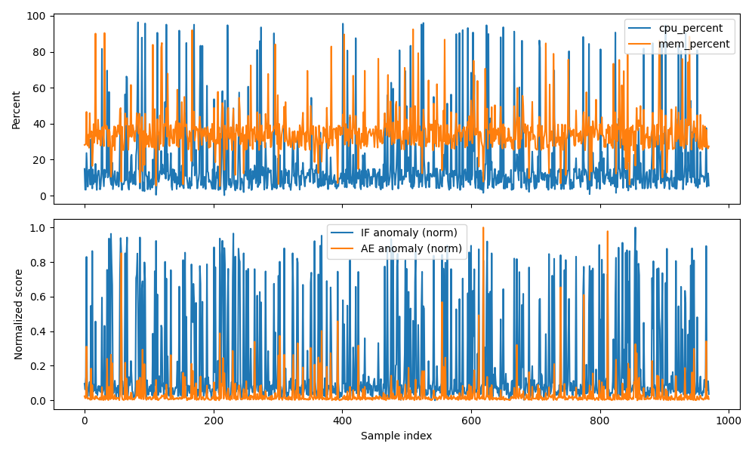
In conclusion, this work demonstrates that Digital Immune Systems can be operationalized as practical, autonomous security mechanisms for cloud-native infrastructures. By bridging immune-inspired theory with reproducible system-level implementation and evaluation, the proposed Cognitive Overlay DIS provides a concrete foundation for future research on adaptive, self-healing cybersecurity architectures.

VIII. SYSTEM DIAGRAMS AND EXPERIMENTAL VISUALIZATIONS
This section presents the essential architectural and experimental visualizations that support the design and evaluation of the proposed Cognitive Overlay Digital Immune System (DIS). To maintain clarity and focus, only a minimal set of figures is included. These figures are selected to directly substantiate the architectural design, runtime behavior, and quantitative performance claims discussed in earlier sections.

A. Cognitive Overlay Digital Immune System Architecture
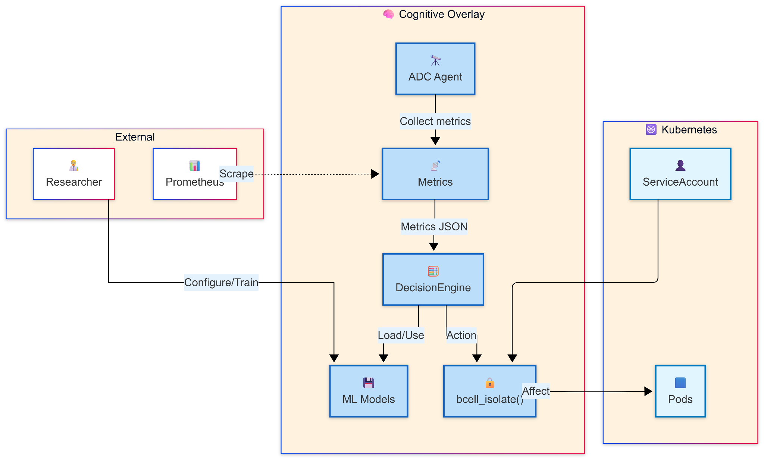

Fig. 1: High-Level Cognitive Overlay Digital Immune System Architecture
Fig.1 illustrates the overall architecture of the proposed DIS operating as a non-intrusive cognitive overlay on a Kubernetes-managed cloud-native environment. The diagram highlights the separation between application workloads, Kubernetes orchestration components, and the DIS layers responsible for sensing, detection, and response. This visualization supports the architectural design principles described in Section III, particularly the overlay-based deployment model and modular separation of concerns.

B. Anomaly Score Dynamics Over Time

Fig. 2: Time-Series Anomaly Scores During Fault Injection
Fig. 2 presents the temporal evolution of anomaly scores generated by the Isolation Forest, autoencoder, and ensemble detection models during experimental execution. Fault injection intervals are reflected through observable score escalations, demonstrating clear temporal alignment between anomalous runtime behavior and detection response. This visualization substantiates the analysis in Section V-B by illustrating how the DIS responds dynamically to runtime disruptions rather than relying solely on static classification outcomes.

C. Precision–Recall Performance Evaluation and Response Safety
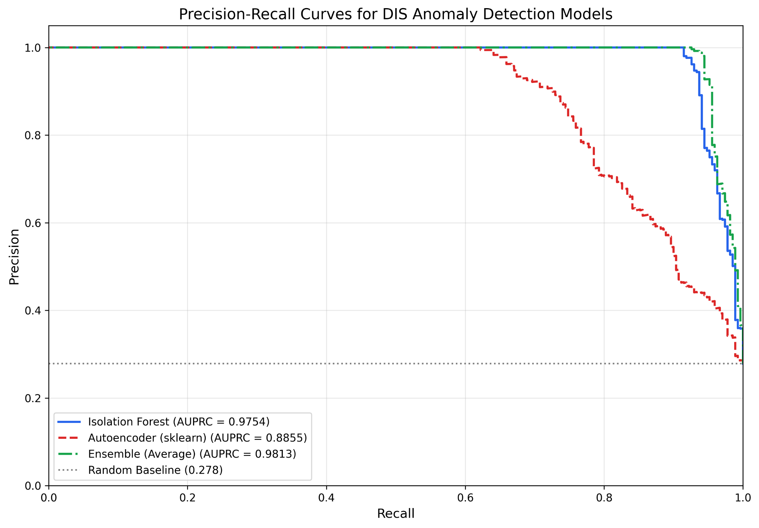

Fig. 3: Precision–Recall Curve and Confusion Matrix for Ensemble Detection
Fig. 3 provides visual evidence of detection performance and response safety for the ensemble-based detection layer. The precision–recall curve illustrates robust performance under class imbalance, highlighting an AUPRC of 0.9813. The accompanying confusion matrix summarizes true positives, true negatives, false positives, and false negatives, supporting claims of low false positive rates and safe autonomous response behavior discussed in Sections V-A and V-D.

D. Summary of Visual Evidence
Collectively, these visualizations reinforce the key contributions of this work by illustrating the system architecture, runtime anomaly detection behavior, and quantitative detection reliability. By focusing on a limited and carefully selected set of figures, this section complements the textual analysis without introducing redundancy, providing clear empirical support for the feasibility and operational validity of the proposed Cognitive Overlay Digital Immune System.

References
[1] L. N. de Castro and F. J. Von Zuben, “Artificial immune systems: Part I—Basic theory and applications,” IEEE Transactions on Evolutionary Computation, vol. 6, no. 3, pp. 239–251, Jun. 2002.
[2] P. Matzinger, “The danger model: A renewed sense of self,” Science, vol. 296, no. 5566, pp. 301–305, Apr. 2002.
[3] S. Forrest, S. A. Hofmeyr, A. Somayaji, and T. A. Longstaff, “A sense of self for Unix processes,” in Proc. IEEE Symposium on Security and Privacy, Oakland, CA, USA, 1996, pp. 120–128.
[4] D. Dasgupta, “Advances in artificial immune systems,” IEEE Computational Intelligence Magazine, vol. 1, no. 4, pp. 40–49, Nov. 2006.
[5] U. Thakare, S. Vidhate, P. Fuldeore, and M. Khan, “Digital Immune Systems for Cybersecurity: A Self-Adaptive Architecture for Modern Digital Infrastructures,” International Conference on Emerging Technologies, 2025.
[6] J. Kim, J. Park, and H. Kim, “Immune-inspired intrusion detection systems: A survey,” ACM Computing Surveys, vol. 54, no. 6, pp. 1–36, 2022.
[7] M. Du, F. Li, G. Zheng, and V. Srikumar, “DeepLog: Anomaly detection and diagnosis from system logs through deep learning,” in Proc. ACM CCS, Dallas, TX, USA, 2017, pp. 1285–1298.
[8] C. C. Aggarwal, Outlier Analysis, 2nd ed. Springer, 2017.
[9] V. Chandola, A. Banerjee, and V. Kumar, “Anomaly detection: A survey,” ACM Computing Surveys, vol. 41, no. 3, pp. 1–58, Jul. 2009.
[10] F. T. Liu, K. M. Ting, and Z.-H. Zhou, “Isolation forest,” in Proc. IEEE ICDM, Pisa, Italy, 2008, pp. 413–422.
[11] J. An and S. Cho, “Variational autoencoder based anomaly detection using reconstruction probability,” Special Lecture on IE, vol. 2, no. 1, pp. 1–18, 2015.
[12] D. M. Nicol, R. Fujimoto, and K. S. Perumalla, “SOAR platforms: Architecture and challenges,” IEEE Security & Privacy, vol. 18, no. 4, pp. 60–68, 2020.
[13] B. Burns, B. Grant, D. Oppenheimer, E. Brewer, and J. Wilkes, “Borg, Omega, and Kubernetes,” Communications of the ACM, vol. 59, no. 5, pp. 50–57, May 2016.
[14] K. Hightower, B. Burns, and J. Beda, Kubernetes: Up and Running, 2nd ed. O’Reilly Media, 2019.
[15] N. Dragoni et al., “Microservices: Yesterday, today, and tomorrow,” in Present and Ulterior Software Engineering, Springer, 2017, pp. 195–216.
[16] R. Basak, S. Mukherjee, and A. Sinha, “An experimental evaluation of a cognitive overlay digital immune system for Kubernetes-based cloud environments,” 2026. [Online]. Available: https://github.com/theujwalthakare/DIS

